H.T No
Regulations:
A14

Sreenidhi Institute of Science and Technology
(An Autonomous Institution)
Code No: 4B202 Date: 15-July-2021 (AN)

B.Tech I-Year II- Semester External Examination, July-2021 (Supplementary)
Engineering Drawing – II (Common to All)

Time: 3 Hours Max.Marks:70

Note: a) No additional answer sheets will be provided.
b) All sub-parts of a question must be answered at one place only, otherwise it will not be valued.
c) Missing data can be assumed suitably.

ANSWER ANY 5 OUT OF 8 QUESTIONS. EACH QUESTION CARRIES 14 MARKS.

Bloom's Cognitive Levels of Learning (BCLL)

Remember | L1 | Apply | L3 | Evaluate | L5
Understand | L2 | Analyze | L4 | Create | L6

 |  |  | BCLL | CO(s) | Marks
1. |  | Construct a diagonal scale of 3:200 i.e 1:66 showing meters, decimeters and centimeters and to measure up to 6 meters. | L3 | CO1 | [14M]
2. |  | Construct a scale of RF = 1/2.5 to show centimeters and decimeters by a Vernier to read millimeters, to measure up to 4 decimeters. | L3 | CO2 | [14M]
3. |  | Draw the development of the lateral surface ofthefrustum of the square pyramidof side of base 30 mm and axis 40 mm, resting on HP with one of the base edges parallel to VP. It is cut by a horizontal cutting plane at a height of 20 mm. | L4 | CO3 | [14M]
4. |  | A square lamina of 30 mm side lies on the ground plane. One of its corners is touching the PP andedge is inclined at 60° to PP. The station point is 30 mm in front ofPP, 45 mm above GP and lies ina central plane which is at a distance of 30 mm to the right of the corner touching the PP.Draw the perspective projection of the lamina. | L4 | CO5 | [14M]
5. | a) | Explain the steps involved in generation of polygon in CAD | L2 | CO6 | [7M]
 | b) | List out the sequence of commands involved in generation of cube in CAD. | L1 | CO6 | [7M]
6. |  | Draw the orthographic view of the below figure  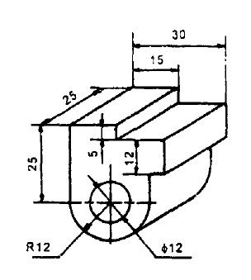 | L3 | CO4 | [14M]
7. |  | Draw the isometric view of figure below  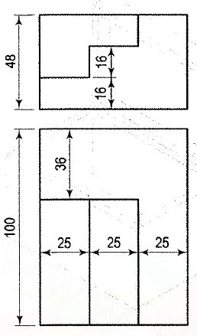 | L3 | CO3 | [14M]
8. |  | Draw the orthographic view of the below figure  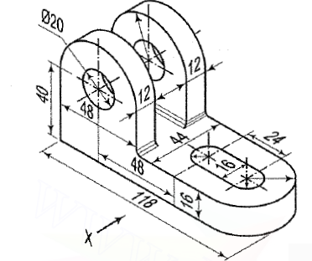 | L4 | CO4 | [14M]

-- 00 -- 00 –

